**Transient evolutionary attractors alter the path toward adaptation**

John P. DeLong and Clayton E. Cressler

University of Nebraska – Lincoln, Lincoln, NE, 68588, USA

**Abstract**

Adaptation requires alignment of traits and environmental conditions. The path toward adaptation, however, is subject to dynamic ecological forces that can shift evolutionary optima, strip populations of genetic variation, and keep populations in a transient state. How these ecological forces alter the path and pace of evolution, however, are not well understood because the backbone of evolutionary theory typically rests on the assumption of ecological equilibrium. Here we directly evaluate how demographic stochasticity alters adaptation using Gillespie eco-evolutionary models (GEMs) to simulate a population growing with simple logistic type dynamics. We compare the eco-evolutionary trajectories generated by GEMs with the expectations of the same system from quantitative genetics and adaptive dynamics and find that 1) transient dynamics can drive evolution toward transient evolutionary attractors that compete with the overall evolutionary stable strategy, and 2) stochasticity both reduces genetic variation, reducing the pace of evolution, and shifts populations toward the transient optima. We further show that harvesting that maintains populations in transient states can redirect evolution away from an ESS and toward optima that are not identified using equilibrium techniques. Our results clarify that considering the path toward adaptation during transient periods can greatly improve our understanding of the path and pace of evolution.

**Introduction**

Adaptation occurs as populations follow paths through trait space toward a good match between traits and the environment. This match can be visualized using a fitness landscape where peaks represent locally optimal trait values (Wright 1932). Populations can evolve up-slope toward these peaks, barring hindrances such as the lack of genetic variation, at least until the landscape changes. The path itself, however, is subject to ecological forces, including eco-evolutionary feedbacks and environmental and demographic stochasticity. Understanding how these forces alter population dynamics and promote or limit adaptation is necessary to be able to identify whether populations are adapted and to predict future evolutionary change.

Fitness peaks can be identified by quantifying the relationship between fitness and traits, using for example adaptive dynamics or quantitative genetics. Paths toward these peaks can be predicted by incorporating mathematical descriptions of the landscape into population dynamic models. A key feature of most approaches is to account for the amount of heritable trait variation in the population, because this limits what part of the fitness landscape is within reach at any given time (Lande 1976, 1982; Abrams et al. 1993a; Abrams and Matsuda 1997, Cortez and Ellner 2010, Cortez 2016). Thus, population mean traits can evolve upslope toward fitness peaks more quickly when there is more heritable trait variation in the population.

However, variation among individuals can have multiple effects on population processes that could alter the path and pace of adaptation. Demographic stochasticity (variation among individuals in *realized* demographic rates, Fig. 1A) has long been recognized to have important effects on the dynamics of adaptation (e.g., through genetic drift; Hey 1999, Lenormand et al. 2009). Demographic stochasticity generates considerable variation around the relationship between fitness and traits (van Daalen and Caswell 2017). For example, although there is a clear fitness-maximizing value of head width in the damselfly *Coenagrion puella*, the realized lifetime reproductive success of individuals was quite variable, and many individuals with the optimal head width realized relatively low fitness (Figure 1B). As such, stochasticity can be an important limit to adaptation, as it can lead to the loss of high-fitness genotypes, moving population mean traits away from adaptive peaks (Crespi 2000).

More recent work has begun to consider the role of demographic heterogeneity (variation among individuals in *expected* demographic rates; Kendall et al. 2011). Demographic heterogeneity can have important effects on ecological dynamics due to the nonlinear relationship between traits and demographic processes (Bolnick et al. 2011). A concave down relationship between a trait and fecundity, for example, could lower the mean fecundity of the population if individual trait variation is high. How demographic heterogeneity is structured within the population (e.g., whether the trait variation is created by genetic differences or cohort effects) has important effects on ecological and evolutionary dynamics (Vindenes and Langangen 2015, Kendall et al. 2011, Stover et al. 2012, Cressler et al. 2017), and can act to reduce the effects of demographic stochasticity (Kendall and Fox 2002).

An important gap in our understanding of the path and pace of adaptation is that current theoretical approaches have not considered how deterministic and stochastic processes interact to drive ecological and evolutionary dynamics on similar timescales (DeLong et al. 2016). Thus far, theoretical studies have focused on the influence of deterministic and stochastic processes on evolution (Rice 2004) or ecology (van Daalen and Caswell 2017, DeLong papers), or the influence of deterministic processes on eco-evolutionary dynamics (Abrams et al. 1993a, Cortez and Ellner 2010, Cortez 2016). This gap limits our fundamental understanding of adaptation in real systems which are subject to these forces.

In this paper, we investigate the pace and path of evolution of a demographic trait (fecundity) in a simple one-species system. Our focus is to contrast the eco-evolutionary outcomes of populations with both demographic heterogeneity and stochasticity with outcomes with models that do not have these features. We do this by comparing the predictions of classic quantitative genetic and adaptive dynamics models (Abrams et al. 1993b, Geritz et al. 1998) with a stochastic approach that allows for dynamic feedback between demographic heterogeneity, demographic stochasticity, ecology, and evolution (Gillespie eco-evolutionary models, GEMs). We also investigate how impacts to the population from the outside (i.e., culling) that keep populations in transient states can alter the evolutionary outcomes. Both of these investigations indicate considerable limitations to the pace of evolution. Our results also uncover a crucial role for population abundance on evolutionary trajectories in non-equilibrium settings. We explore this last issue below.

**Transient versus equilibrium evolutionary expectations**

We first clarify the quantitative genetics (QG) and adaptive dynamics (AD) approaches to modeling adaptation in order to better contrast the GEM approach. Lande (1976, 1982) derived an expression for the dynamics of trait change from classical quantitative genetics (Falconer 1960), showing that the average trait in a population changes at a rate that is proportional to both genetic covariance and the gradient of fitness with respect to the trait. Work by Peter Abrams and colleagues (Abrams et al. 1993a,b, 1997) integrated Lande’s model of trait change with models of ecological dynamics by assuming that fitness could be represented by the per-capita growth rate of the evolving population. These QG models are eco-evolutionary models, with the relative timescales of ecological and evolutionary dynamics given by the genetic (co)variance.

The adaptive dynamics approach (Geritz et al. 1998) often leads to identical evolutionary predictions (Abrams et al. 1993), but arrives there through a different analysis. Trait evolution, in adaptive dynamics, happens by a process of mutation and invasion. Specifically, the analysis asks whether a monomorphic population could be invaded by a mutant population with a different trait value (determined by the dominant eigenvalue [or Lyapunov exponent] of the system evaluated at the mutant-free attractor; Geritz et al. 1998, Metz et al. 1992). The direction of trait evolution is given by the derivative of this “invasion fitness” with respect to the trait.

Another shared feature of the QG and AD approaches is changes in ecological variables are typically assumed to be much faster than changes in trait dynamics. The AD approach assumes a strict separation of timescales, whereas the QG approach typically assumes that the genetic covariance term is small, slowing evolution relative to ecology (although there has been recent work relaxing this assumption and showing it can have non-intuitive effects on both ecological and evolutionary dynamics; Cortez and Ellner 2010, Cortez and Weitz 2014, Cortez 2016). The consequence of this assumption is that the dynamics of the system tend to be determined much more by the dynamics of the “fast” subsystem (Cortez and Ellner 2010). In an eco-evolutionary context, that means that the system will move quickly to an ecological equilibrium that will change slowly as the mean trait changes. Under this view, then, the transient behavior of the ecological system has very little affect on the path towards adaptation.

For example, consider this simple modified logistic model of population growth (Appendix S1). The model is:

Equation 1.

where *R* is population abundance, *t* is time, *b*max is maximum birth rate (i.e., fecundity), *d*min is minimum death rate, and *b*s and *d*s characterize the effect of population abundance on the realized birth and death rates, respectively. We consider the case where *b*max (i.e., fecundity) is evolving and connected to mortality through a trade-off described by an accelerating function:

, Equation 2

where *s* is the value of *d*min when *b*max = 1. Using the QG approach (Lande 1976; Abrams et al. 1993a), the dynamics of the population mean are proportional to heritable trait variation (the product of heritability *h*2 and the amount of additive genetic variation *V*) and the gradient of the per-capita growth rate with respect to , evaluated at the mean: (Appendix S1):

Equation 3

In this model, the mean trait will evolve toward the evolutionary equilibrium . It is straightforward to show that this equilibrium is an evolutionarily stable strategy (ESS) that maximizes fitness.

Alternatively, we can use expected lifetime reproductive success (LRS) as a measure of fitness, which is the product of the expected birth rate given *b*max and lifespan (1/death rate). In this model, this is

Following Lande’s derivation, the dynamics of the population mean would be given by

Equation 4

At the ecological equilibrium , the equation for the trait dynamics becomes

where . Although this expression is more complicated than the one in Eq. (3), it has the same evolutionary equilibrium: (Appendix S2).

However, if the system is away from the ecological equilibrium, the evolutionary equilibrium is:

Equation 5

Equation 5 suggests that, when the system is undergoing transient ecological dynamics, the trait may actually evolve towards a different evolutionary equilibrium than the one that is predicted by a classic QG approach. This means that in any scenario where forces (such as stochasticity, harvesting, or due to individual trait variation) are acting on the population to slow down its ecological approach to equilibrium, evolution would proceed towards equilibria that are not the ESS. We refer to these equilibria as transient evolutionary attractors (TEAs). These TEAs are critical to understanding how transient dynamics and external impacts can redirect populations toward trait values that would be viewed as maladaptive values given an ESS framework.

**Methods**

*Modeling approaches*. We studied the evolution of given Equations 1 and 2 using quantitative genetics (Equation 3), adaptive dynamics, and GEMs. The adaptive dynamics approach simply finds the ESS value of *b*max (ESS), whereas the QG approach provides the trajectory towards the ESS. Neither approach accounts for the effect of demographic heterogeneity and demographic stochasticity on variation in realized fitness among individuals (van Daalen and Caswell 2017) or for the effect of stochasticity on the loss of trait variation through drift. In contrast, GEMs account for both of these sources of individual heterogeneity. Thus, GEMs provide an opportunity to determine whether and how different sources of individual heterogeneity – which is a generic feature of all natural populations – play a role in determining the pace and path of evolution.

*GEMs*. GEMs simulate the dynamics of an ODE model by breaking down rates of change for the population as a whole into discrete birth and death events (DeLong and Gibert 2016; DeLong and Luhring 2018; DeLong and Belmaker 2019). GEMs build on the standard Gillespie algorithm that simulates ODE models (Gillespie 1977; Yaari et al. 2012). A standard Gillespie algorithm approach to simulating Equations 1-3 would assume that all individuals have identical trait values, thus adding demographic stochasticity to the models, but not demographic heterogeneity. GEMs incorporate demographic heterogeneity by giving every individual a trait value drawn from a normal distribution with known mean and variance. An individual’s trait value determines its probability of giving birth or dying. The loss and addition of individuals from the population affects both population dynamics and the dynamics of both the mean and variance of the trait distribution, without needing to specify explicit equations for the trait dynamics. Note that a key difference from the QG approach, in which the trait variance is constant, is that GEMs account for genetic drift as genetic variation is lost stochastically.

We first examined the role of individual variation in *b*max on the ecological dynamics of this model when no evolution was possible. To do this, we set heritability (*h*2) at 0 and introduce variation in *b*max in the population with a CV = 0.3. Because in our model, the *d*min is locked to *b*max, we examined whether variation in *b*max alone, *d*min alone, or combined, influence the dynamics. This examination also confirmed whether in the absence of variance and heritability that the GEM dynamics reduced to a standard Gillespie simulation of the model dynamics.

We then evaluated differences between the GEM, QG, and adaptive dynamics approaches using three sets of comparisons. In the first set, we compare outcomes across different values of *b*s and *d*s, which set the strength of density dependence on birth rates and death rates, respectively (Equation 1). Varying these two parameters effectively changes the carrying capacity of the system such that starting at any given population size means starting at a different distance from equilibrium. These parameters also influence the effect of population abundance on the TEAs (Equation 5), altering the location of the attractors across scenarios. We expected that these simulations would vary in the amount of stochastic loss of trait variation because of the different rates populations would grow at the start of the simulation. We initiated these populations at a population abundance of five and allowed them to grow.

In the second set of comparisons, we used the same variation in density dependence but added a culling term to maintain the population at the initial starting value of five. At each time step within the GEM algorithm, we randomly removed individuals to keep the population in a transient phase without biasing the trait distributions. These simulations allowed us to test the prediction that the populations would evolve toward the TEA given by population size and the density-dependence terms (Equation 5). Because the density dependence terms influence the TEA, we predicted that the traits would evolve toward a different transient optimum in each scenario.

Finally, we asked whether harvesting of a population that has already achieved an ESS trait and ecological equilibrium would shift it toward a state in which it would evolve toward a TEA as long as the press perturbation persisted. We do this across three levels of culling and predicted that populations in each scenario would move to the TEA for that population size. We also predicted that stochastic loss of genetic variation could slow approach toward the TEA.

To evaluate patterns in individual fitness across GEM simulations, we tracked the number of reproduction events and lifespan for each individual. This allows us to show the realized relationship between the trait *b*max and lifetime reproductive success, akin to Figure 1B. We do this for the initial population (born before time step 1) and the population toward the end of the simulation (born after time step 50). For the latter, we only included individuals that died before the end of the simulation. We then determined whether the optimal trait as determined by adaptive dynamics and the endpoint of both QG and GEM outcomes lines up with the trait that maximized realized fitness.

In all simulations except with an ESS starting point, we started the populations with *b*max = 1.8, *d*min = 0.3, and thus s = 0.0926. The ESS *b*max for this system is 5.4, which means the ESS *d*min is 2.7. We make density dependence in births and deaths symmetrical, so *b*s = *d*s, and set these equal to 0.1, 0.05, and 0.01 across scenarios. With these values, the equilibrium abundance (*K*) across scenarios at the start of the simulation is 7.5, 15, and 75, and at the ESS (since the equilibrium is a function of the parameters) it is 13.5, 27, and 135. We initialize populations at five individuals in all simulations except for the last simulation, which was initiated at both the equilibrium traits and abundance. We ran each simulation for 60 time steps, which was long enough to reach the ecological equilibrium in all non-evolutionary scenarios. Unless otherwise indicated, the variation in *b*max was set with a CV = 0.3 and the heritability was set at 0.75.

**Results**

Reducing heritability to zero, effectively eliminating evolution by natural selection, revealed that trait variation *per se* altered the dynamics of the system (Figure S1). Variation in *b*max alone reduced the equilibrium abundance of the population. Variation in *d*min alone had little effect on the population, but combined with *b*max, *d*min reduced the equilibrium abundance of the population even more (by about 7% below the expected equilibrium). This result indicates that variation is one factor that limits the progression of populations in the next set of simulations from achieving the expected equilibria.

In our first set of simulations, in which we varied only the strength of density dependence, we found that all populations grew and evolved *b*max in the direction of the ESS (Figure 2, 2nd and 4th rows). Yet, no population was able to grow or evolve as fast as expected from QG (Figure 2, 1st and 2nd rows). Furthermore, no population appeared on track to reach the ESS trait value and equilibrium, and extending the time frame of the simulation did not change this, as both traits and abundances were leveling out by the end of these simulations. We also found that populations with steeper density dependence slopes (i.e., lower *K*) experienced greater initial loss of trait variation (Figure 2, 3rd row), slowing the pace of evolution relative to that expected by quantitative genetics with variation maintained at the initial value further than when density dependence was weaker (Figure 1, second row). At intermediate and low density dependence, the initial loss of trait variation was regained. There was still a considerable discrepancy between the QG expectation and the GEM outcome even after adjusting the QG expectation to account for the realized standing trait variance (Figure 1, second row).

In each of these scenarios, trait evolution stalled out before reaching either the ESS or the TEA (Figure 2, 3). In the case of strong density dependence (Figure 2,3, left column/plot), there may have been additional capacity to continue to evolve toward the TEA/ESS, but the population showed considerable stochasticity, essentially oscillating in place. With weaker density dependence, populations grew less stochastically but stalled out in a region of the fitness landscape that was exceptionally flat, with little indication that it was steep enough to overcome the stochasticity that was present.

When we introduced a cull and maintained population abundance at the initial level of five, we found that populations did not evolve toward the ESS at all (Figure 4, 2nd row). At the strongest density dependence, the population appeared to not move much at all, while with stronger density dependence, the populations appeared to be evolving lower *b*max, in the direction of the TEAs which were in these cases below the initial values. In this set of simulations, all populations lost trait variation in the beginning, and the continued culling maintained that variation at a low level, which continued to limit further evolution.

In our third set of simulations, we applied a persistent cull of populations that had already achieved their ESS trait and abundance values. Evolution in these scenarios generated clear movement of the populations toward the population-specific TEAs that varied with the magnitude of the cull (Figures 5,6). Rather than returning to the ESS, populations reduced to a lower abundance shifted their path immediately to head upslope toward the abundance-determined TEA (Figure 6). The populations followed the fitness contour generated by Equation 5.

**Discussion**

Evolutionary theory today encompasses a wide range of modeling techniques and frameworks that facilitate an understanding of how populations evolve and adapt to their environments. From eco-evolutionary quantitative genetics models to individual-based models, integral projection models, matrix models, and population genetics, it is increasingly clear that evolution can be surprising and yet logical at the same time. Our results using GEMs contribute to this dichotomy by demonstrating that the stochasticity of populations undergoing transient dynamics induces qualitatively and quantitatively different outcomes relative to techniques that overlook this process. Simulated populations cannot evolve toward transient attractors if the system is assumed to be at equilibrium. The transient dynamics that unfold during the GEM simulations respond to underlying fitness contours that are invisible with an equilibrium lens but that lay out a straightforward evolutionary path that transient populations can follow. With the rapid environmental change occurring throughout the world today, we anticipate that transient theories of evolution will provide crucial insights into the adaptation of wild populations.

In addition to the effects caused by the transient fitness landscapes, our results indicate substantial challenges to evolution proceeding according to quantitative genetics expectations. The presence of individual trait variation (and demographic heterogeneity), although required for evolution to proceed, itself can change the ecological dynamics. In our case, by suppressing population sizes, this variation simultaneously facilitated evolution and maintained the system in a transient state, limiting evolution. Individual demographic stochasticity, abundantly displayed in our results, clearly stripped individuals of their expected fitness benefits while allowing individuals with low fitness traits to have high fitness. This effect should result in a greatly flattened fitness gradient relative to the expectations from quantitative genetics, greatly reducing the rate of evolution. Finally, population-level stochasticity, the aggregate change in sequence of events, generated heightened variation in population size for small populations, both keeping populations in transient states and leading to substantial loss of genetic variation. All together, these forces substantially slowed evolution relative to expectations generated from assumptions of large population size, equilibrium conditions (fast ecology), and deterministic trait-fitness benefits.

Increasing evidence indicates that ecological dynamics can play a crucial role in driving evolution. Furthermore, evolution within systems not at equilibrium, and rather displaying transient dynamics, can alter the ecological dynamics and therefore reset the selective forces acting on the population. Our results further this finding, demonstrating that even simple, single-species models can facilitate not just eco-evolutionary dynamics but transient attractors that may compete with the overall evolutionary attractor in the system. By relaxing the assumption of fast ecology/slow evolution or equilibrium conditions, and taking into account the full consequences of individual variation and stochasticity, we may generate more realistic predictions for evolution. Given the expectation that human impacts on the environment are increasing, bumping populations out of their steady-state conditions and into more transient regimes, this understanding is likely to be more critical going forward.

Our results also have clear implications for managed populations. Economically important populations, from fisheries to ungulates and invasive species, may show substantial changes in traits in response to random or trait-biased harvesting. Some of the observed changes represent challenging evolutionary puzzles. Understanding evolution in these populations may require a disequilibrium approach, because harvested populations are by definition being held below their potential equilibrium. To the degree that these populations show density dependence in their birth or death rates, similar to but not necessarily exactly following the birth-death logistic model, they are likely to also display TEAs that could draw their traits away from the starting values, whether those initial values represented ESS traits or not. Harvesting our simulated population at something near the maximum sustainable yield, for example, could nearly halve the fecundity of the population. In the birth-death logistic model, the ecological equilibrium depends on these traits, and so evolution toward the TEA would further alter the system and potentially lead to unexpected shifts in both traits and abundance. [Example from a real life fishery?]

In conclusion, our results indicate that individual variation and stochasticity represent severe hindrances to evolution, at least with respect to the expectations from deterministic fitness outcomes, equilibrium conditions, and evolution of mean-level traits. Furthermore, focusing on evolution in transient states revealed powerful competing evolutionary attractors that have not factored into much (if any) current thinking on the pace and path of adaptation. Becoming aware that evolution is relatively fast, and that many populations are in transient states rather than equilibrium states, may be essential for a fuller understanding of adaptation.

**References**

Abrams, P. A., Y. Harada, and H. Matsuda. 1993. On the relationship between quantitative genetic and ESS models. Evolution 47:982–985.

Bolnick, D. I., P. Amarasekare, M. S. Araújo, R. Bürger, J. M. Levine, M. Novak, V. H. W. Rudolf, et al. 2011. Why intraspecific trait variation matters in community ecology. Trends in Ecology & Evolution 26:183–192.

Cressler, C. E., S. Bengtson, and W. A. Nelson. 2017. Unexpected nongenetic individual heterogeneity and trait covariance in *Daphnia* and its consequences for ecological and evolutionary dynamics. The American Naturalist 190:E13–E27.

DeLong, J. P., and J. Belmaker. 2019. Ecological pleiotropy and indirect effects alter the potential for evolutionary rescue. Evolutionary Applications 12:636–654.

DeLong, J. P., V. E. Forbes, N. Galic, J. P. Gibert, R. G. Laport, J. S. Phillips, and J. M. Vavra. 2016. How fast is fast? Eco-evolutionary dynamics and rates of change in populations and phenotypes. Ecology and Evolution 6:573–581.

DeLong, J. P., and J. P. Gibert. 2016. Gillespie eco-evolutionary models (GEMs) reveal the role of heritable trait variation in eco-evolutionary dynamics. Ecology and Evolution 6:935–945.

DeLong, J. P., and T. M. Luhring. 2018. Size-dependent predation and correlated life history traits alter eco-evolutionary dynamics and selection for faster individual growth. Population Ecology 60:9–20.

Gillespie, D. T. 1977. Exact stochastic simulation of coupled chemical reactions. The Journal of Physical Chemistry 81:2340–2361.

Lande, R. 1976. Natural selection and random genetic drift in phenotypic evolution. Evolution 30:314–334.

van Daalen, S. F., and H. Caswell. 2017. Lifetime reproductive output: individual stochasticity, variance, and sensitivity analysis. Theoretical Ecology 10:355–374.

Yaari, G., Y. Ben-Zion, N. M. Shnerb, and D. A. Vasseur. 2012. Consistent scaling of persistence time in metapopulations. Ecology 93:1214–1227.

Figure 1. Variation in the relationship between traits and fitness.

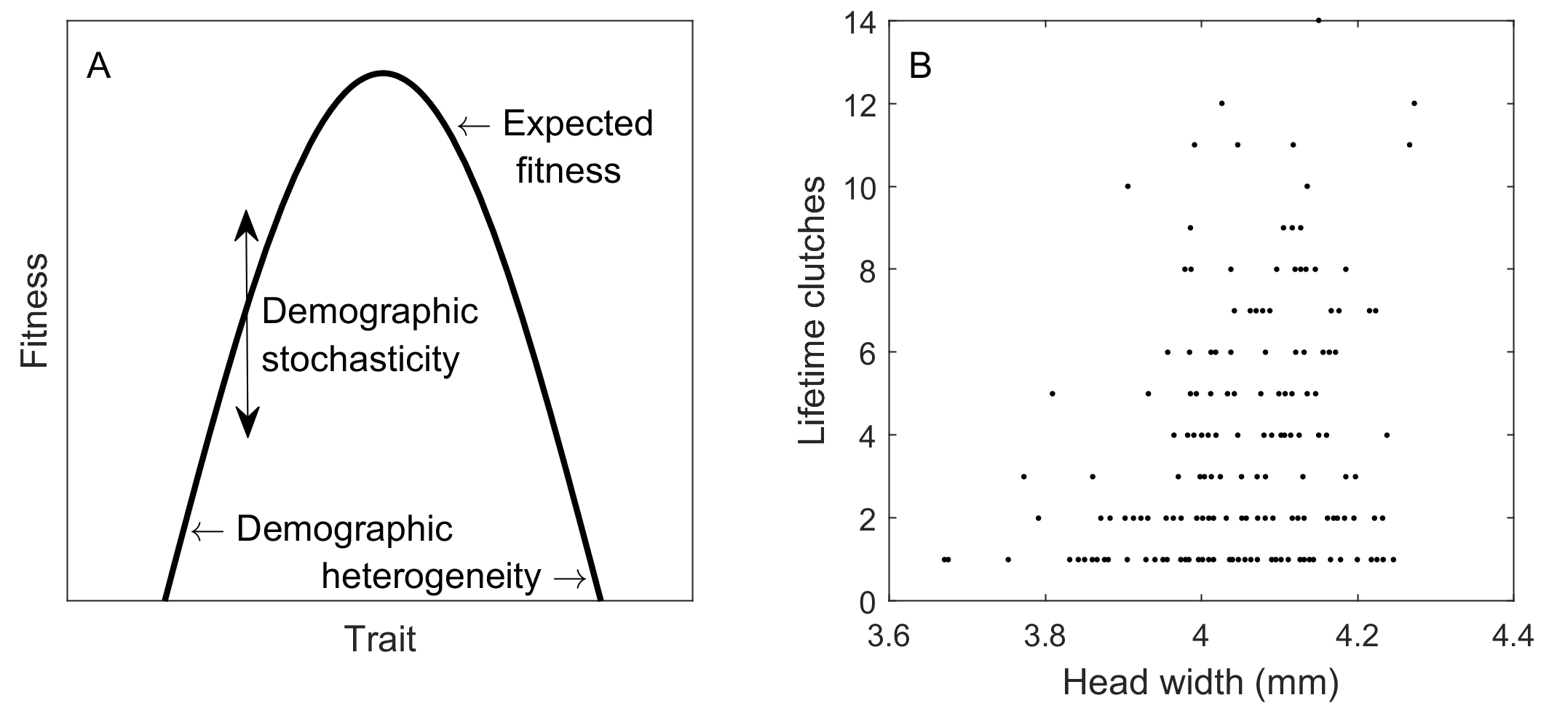

Figure 2. Results of Gillespie eco-evolutionary model (GEM) simulations of the birth-death logistic model. The rows show from top to bottom population abundance (y axis limits vary), mean *b*max, and variance in *b*max. The columns show three levels of density dependence in birth and death rates (values of *b*s and *d*s), decreasing in strength from left to right (). The GEM simulations and middle 50% of observations are in purple and light purple, respectively. The quantitative genetics (QG) solution is in bold orange and the evolutionary stable strategy (ESS) is shown with a dashed orange line in the top two rows and a solid vertical line in the bottom row. The QG solution accounting for the loss of trait variation (third row) is a dashed cyan line. The initial traits and equilibrium abundances are show with dashed black lines, and the transient evolutionary attractors (TEAs) are in pink (dashed in row two and solid vertical in row four). Lifetime reproductive success at the beginning (gray dots) and at the end of the simulation (black dots) as a function of the *b*max trait including only individuals that completed their lives.

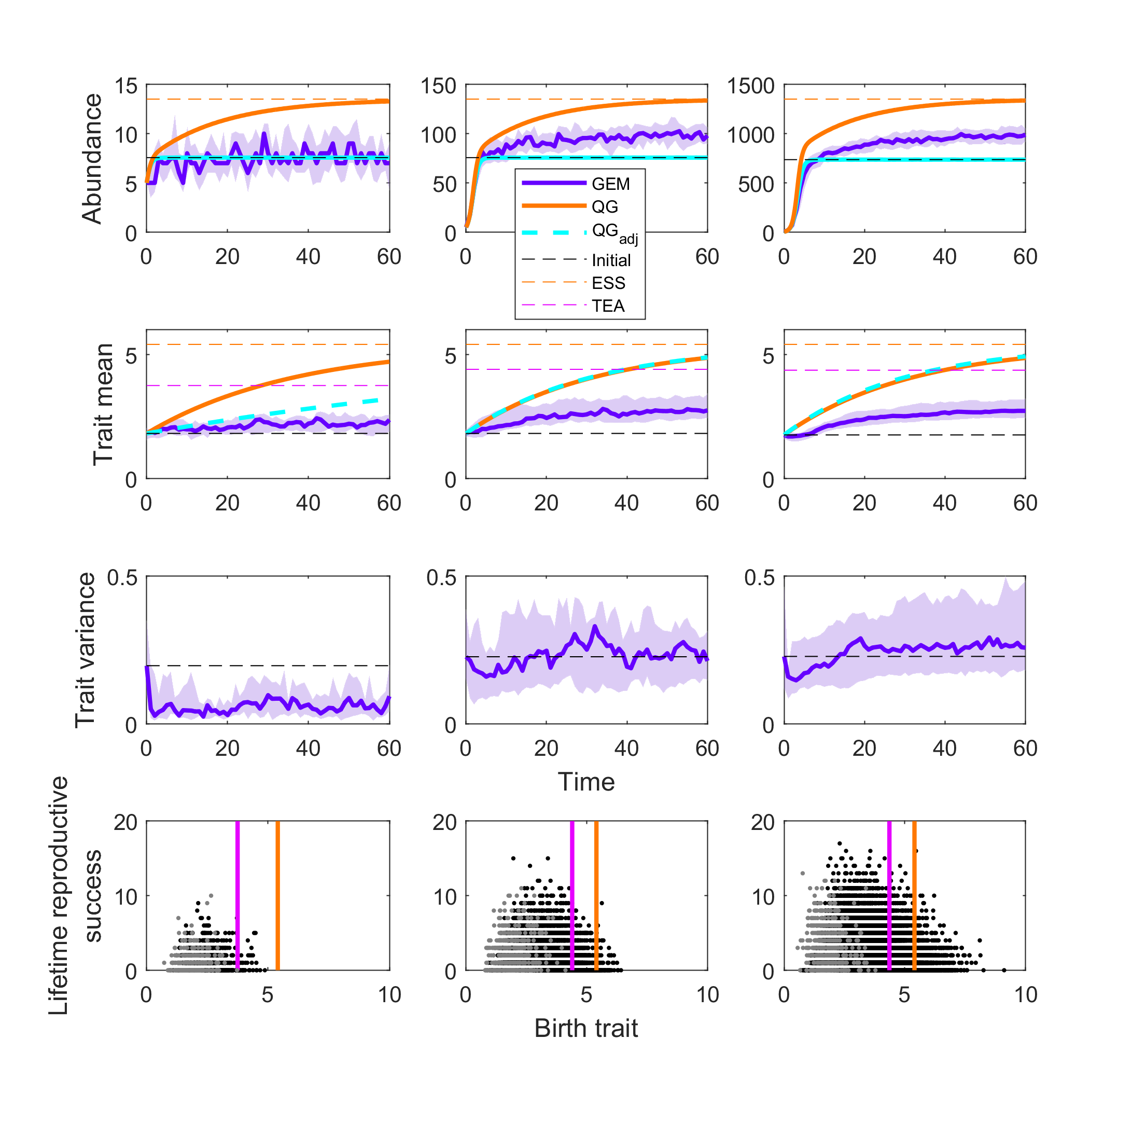

Figure 3. Fitness landscapes of the systems represented in Figure 2.

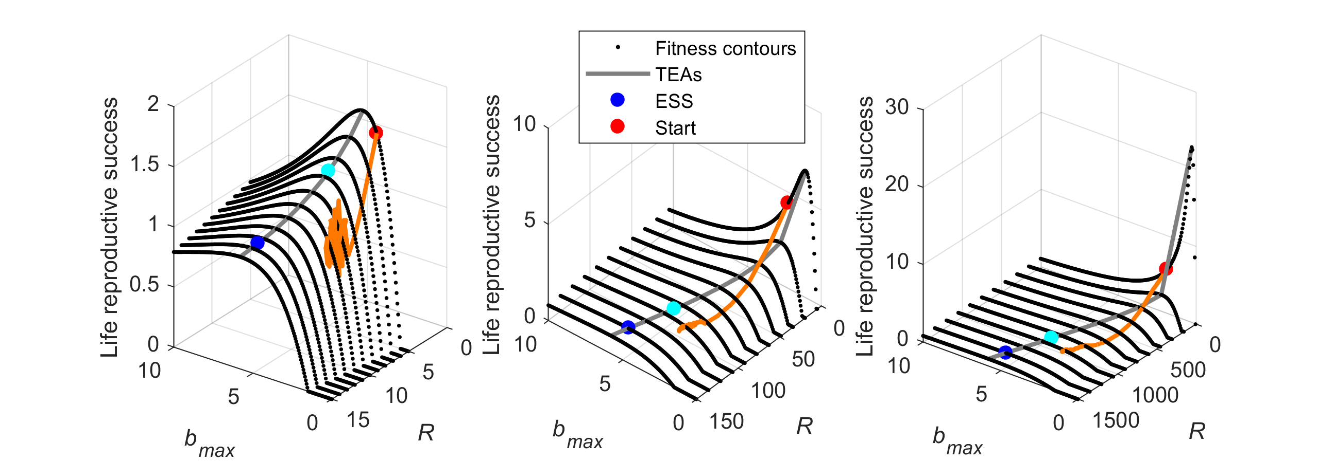

Figure 4. Results of Gillespie eco-evolutionary model (GEM) simulations of the birth-death logistic model for populations culled to five individuals. Layout the same as in Figure 2, but quantitative genetics model with culling was not analyzed.

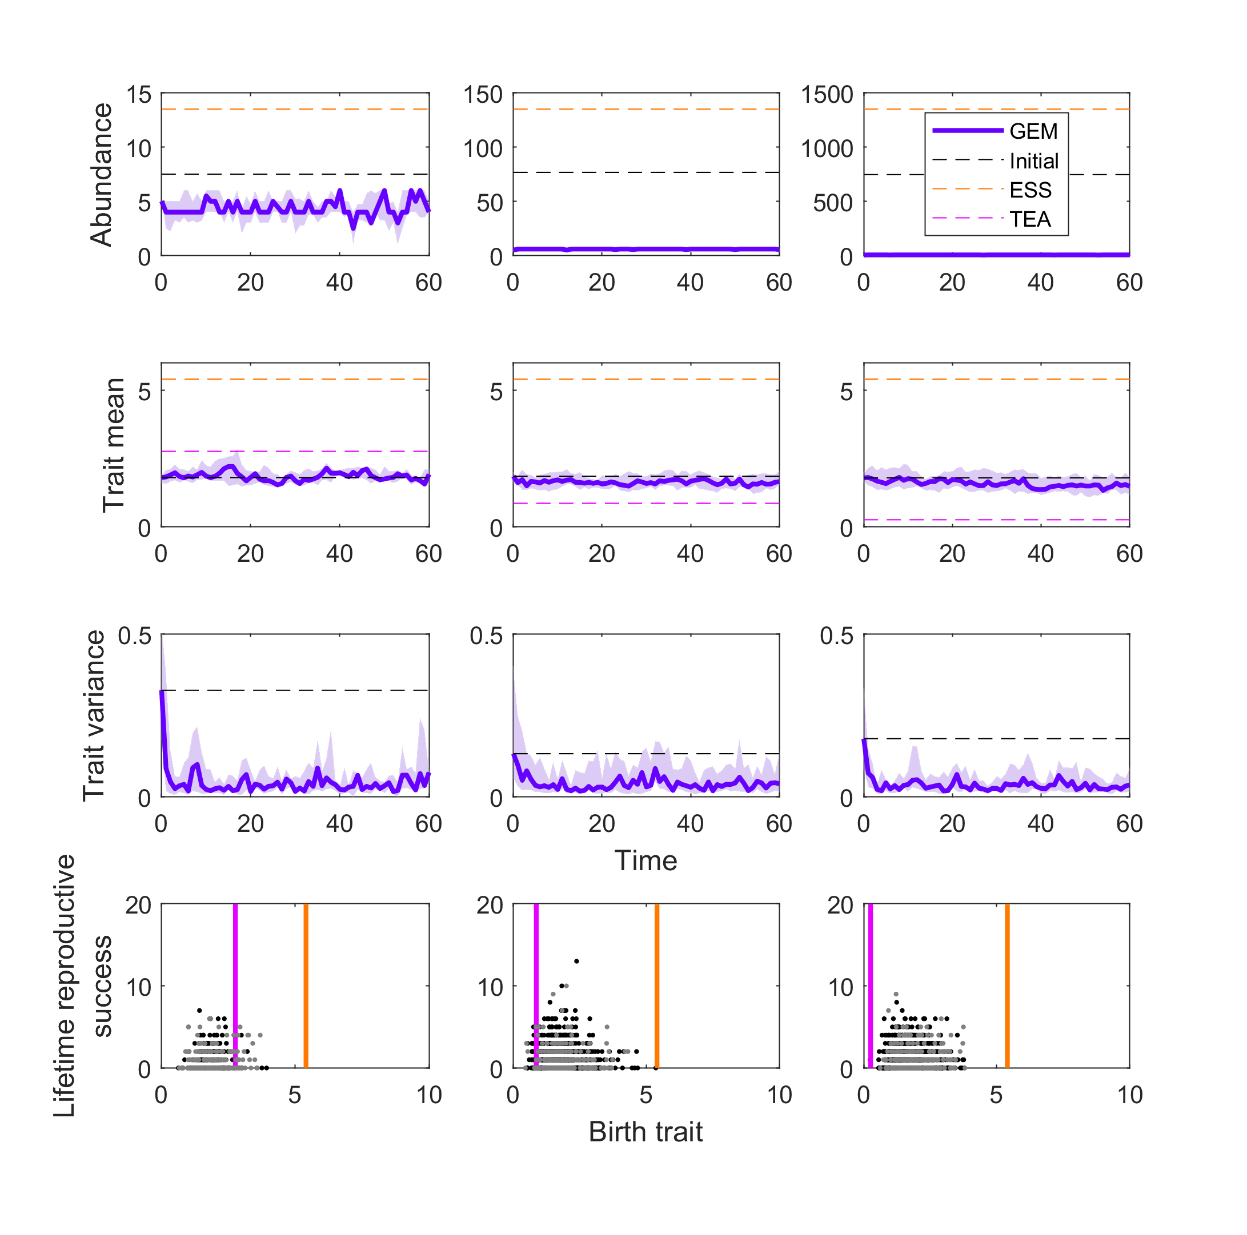

Figure 5. Results of Gillespie eco-evolutionary model (GEM) simulations of the birth-death logistic model for populations culled to five individuals from the starting point at the ESS trait and the equilibrium abundance. From left to right, the population is culled more severely (to 100, 50, and 5 from left to right). Layout the same as in Figure 2.

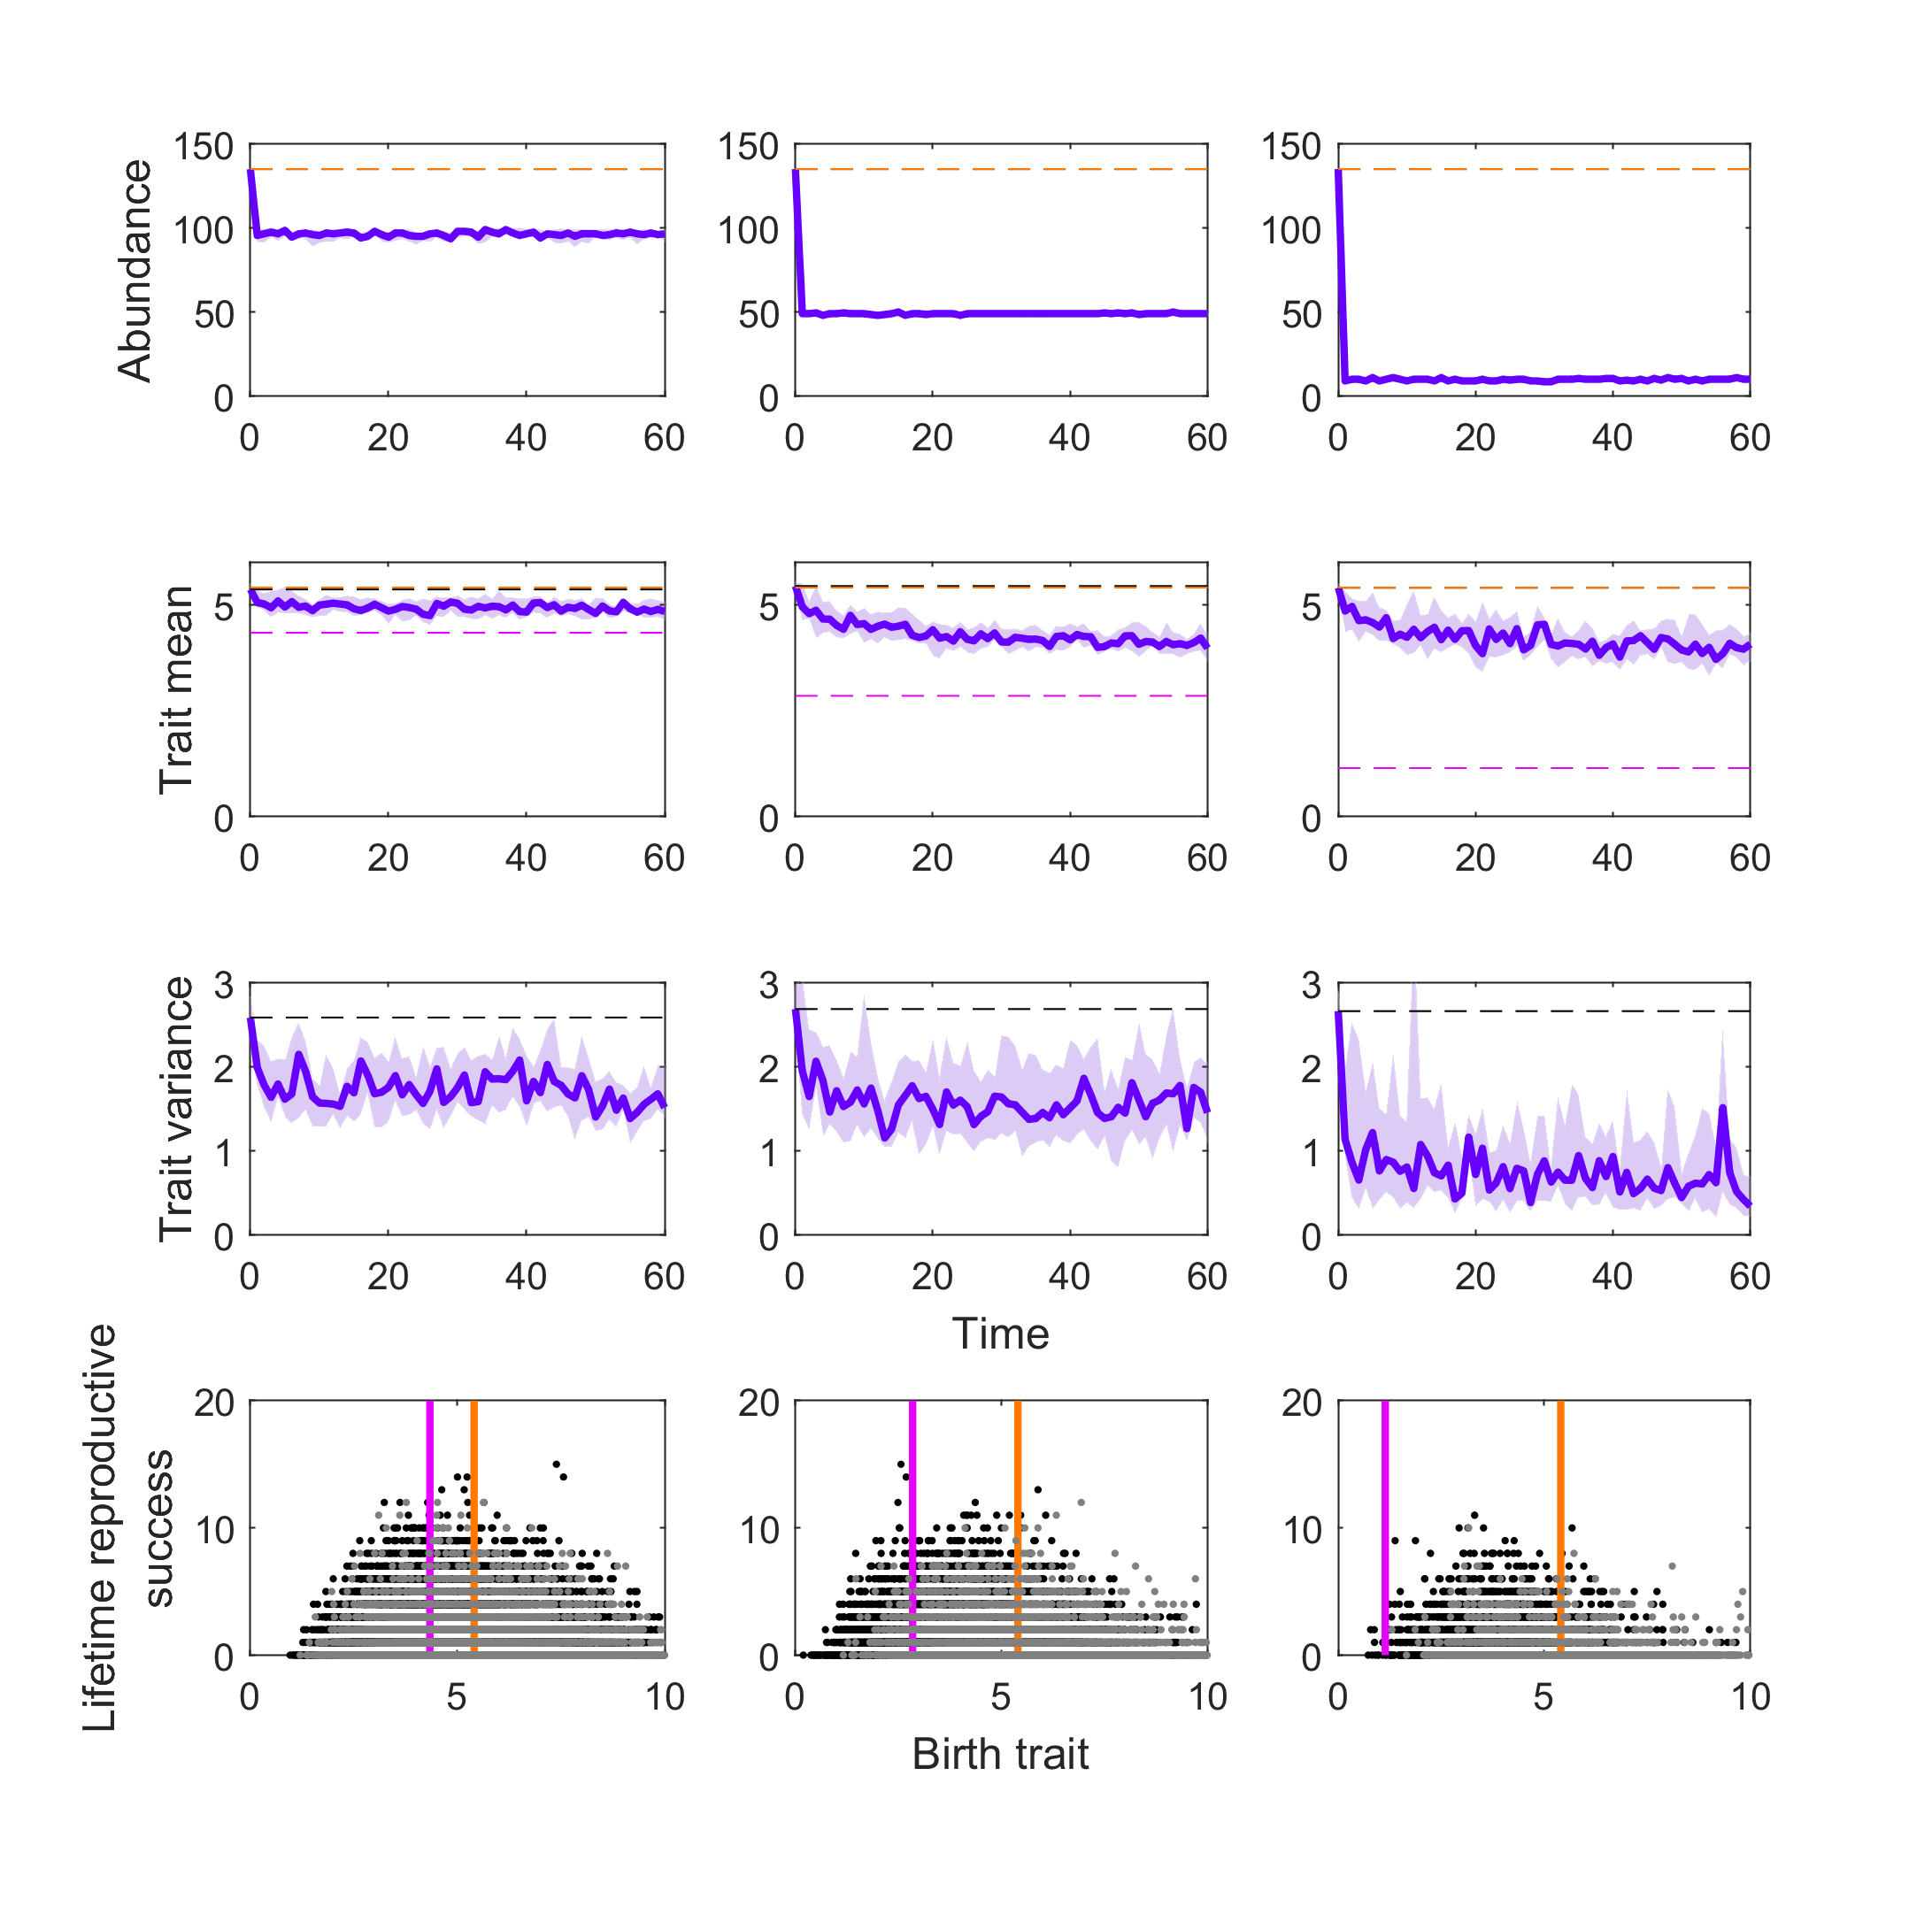

Figure 6. Transient fitness landscapes for the birth-death logistic model with three levels of culling and the weakest density dependence (*b*s = *d*s = 0.01). The colored lines represent the trajectories from Figure 4, with orange being a cull to 100, purple being a cull to 50, and green being a cull to 5 individuals. Each population is evolving toward their local TEA (color coded to match trajectories). The populations started at the ESS trait and equilibrium abundance (blue dot).

